Leave the Leaves Infographic Name: ___________________________ Date: ____________
This image from: https://www.technokids.com/blog/technology-integration/what-is-an-infographic/
Image on page two is from Wired.com

Teach the Community To Leave the Leaves:
Create a poster for our community that shares why removing leaf litter harms our environment.
Your poster must contain:
- The words: Leave the Leaves and environment or ecosystem
- A set of data that has been turned into a picture or graph (or pictorial graph, see below)
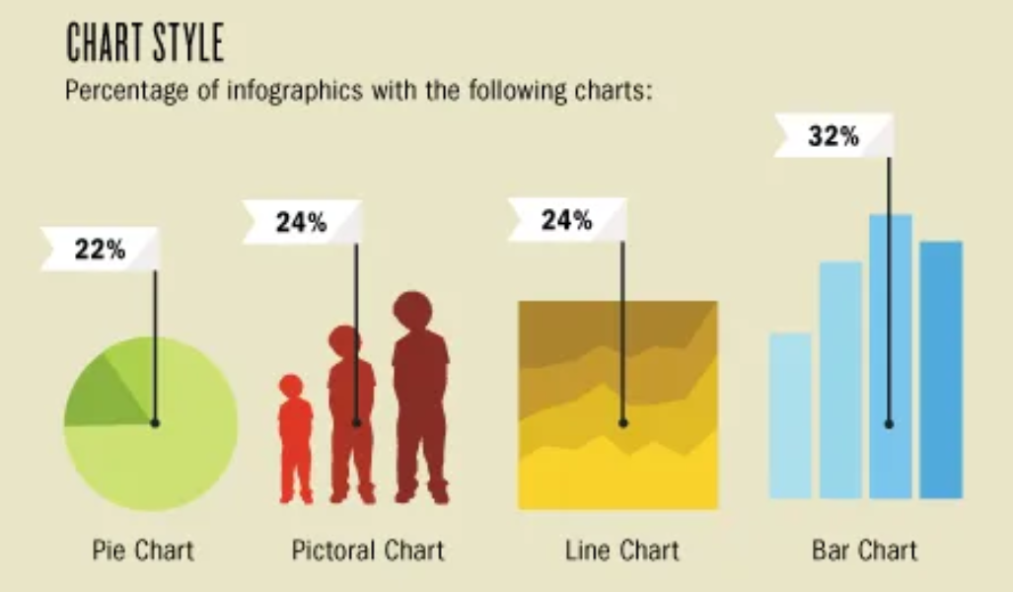
For example, your infographic could highlight the benefit to our waterways, insects, amphibians, birds, or soil enrichment. Here is a helpful link to gather data: Life in the Leaf Litter as well as ____
Your data set should lead you to your pictures and graphs. For example, if you are sharing which species of birds depend on bugs in the leaf litter you could use bird outlines and write data on them.
- The clear instructions for the reader to leave the leaves along with a leaf visual
- A Title. Your title should clearly specify the reason you are highlighting for leaving the leaves. Ie: Leave the Leaves to Protect our Watershed, or Leave the Leaves to Help The Strength of our Foodweb
- The sources of your data should be clearly listed (credits)
- Your name

Use this space to write your facts:

